The EmpowerService is typically installed in

C:\Program Files (x86)\EmpowerNET\2.0\EmpowerService

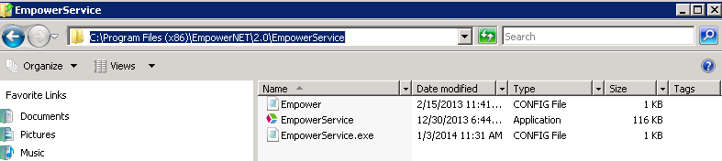

Every 15 minutes the EmpowerService looks to see if the version of the database pointed to by its empower.config file (found in the same folder as the EmpowerService exe) is a different version from the EmpowerWin installed on the server.

If it is, the EmpowerService uninstalls EmpowerWin and reinstalls it.

The EmpowerService.exe.config file (found in the same folder as the EmpowerService exe), tells EmpowerService the folder in which EmpowerWin is installed.

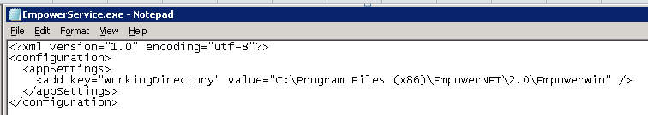

Sometimes at Quality, the reinstall isn’t successful which means there isn’t an EmpowerWin executable on Quality’s server.

Because EmpowerService really runs EmpowerWin, EmpowerService won’t start unless EmpowerWin is installed.

To solve the problem, use EmpowerSupport to install EmpowerWin on Quality’s server (computer name is 2008QUAL).

Then got to Services to confirm that EmpowerService is running.

Client Receives Error Message From EmpowerWin While Client is Updating

Check to see if the Service is running.
Log into the server. Run Administrative Tools, Services, check status of Empower service.

Restart if uncertain.

Check to see if the client can find the server the service is running on.
Use Active Directory to get the DNS name of the Server. This is also going to be in the error message.

Run the CMD prompt from the client computer.

Ping the DNS name of the server. Check the IP address of the DNS Server in the results. If the DNS Server IP address is wrong, fix it, then run IPCONFIG/flush dns on the cliet computer and try again.

